**High-Level Design (HLD)**

**Concrete Compressive Strength Prediction**

|  |  |
| --- | --- |
| Written By | SHREYAS KHADYE  SUDHANSU GOUDA |
| Version | 1.0 |
| Date | 01/04/2023 |

**Document Change Control Record**

|  |  |  |  |
| --- | --- | --- | --- |
| **Version** | **Date** | **Author** | **Comments** |
|  |  |  |  |
|  |  |  |  |
|  |  |  |  |
|  |  |  |  |
|  |  |  |  |
|  |  |  |  |
|  |  |  |  |
|  |  |  |  |
|  |  |  |  |
|  |  |  |  |
|  |  |  |  |
|  |  |  |  |
|  |  |  |  |
|  |  |  |  |
|  |  |  |  |

Review

|  |  |  |  |
| --- | --- | --- | --- |
| **Version** | **Date** | **Reviewer** | **Comments** |
|  |  |  |  |

**Approval**

|  |  |  |  |  |
| --- | --- | --- | --- | --- |
| **Version** | **Review date** | **Reviewed By** | **Approved By** | **Comments** |
|  |  |  |  |  |

**Abstract**

The quality of concrete is determined by its compressive strength, which is measured using a conventional crushing test on a concrete cylinder. The strength of the concrete is also a vital aspect in achieving the requisite longevity. It will take 28 days to test strength, which is a long period. So, what will we do now? We can save a lot of time and effort by using Data Science to estimate how much quantity of which raw material we need for acceptable compressive strength. The aim is to build a solution that should able to predict the compressive strength of the concrete.

1. Introduction

**1.1 Why these High-Level Design Documents?**

What does a high level document mean?

A high-level design document (HLDD) describes the architecture used in the development of a particular software product. It usually includes a diagram that depicts the envisioned structure of the software system. Since this is a high-level document, non-technical language is often used. The HLD will be:

* Present all of the design aspects and define them in detail.
* Describe the user interface being implemented.
* Describe the needed Python libraries for the coding.
* Describe the performance requirements.
* Include design features and the architecture of the project.
* List and describe the non-functional attributes like:
  + Security
  + Reliability
  + Maintainability
  + Portability
  + Reusability
  + Application Compatibility
  + Resource Utilization
  + Serviceability

**1.2 Scope**

The HLD documentation presents the structure of the system, such as the database architecture, application architecture(layers), application flow (Navigation), and technology architecture, The HLD uses non-technical and mildly-technical terms which should be understandable to the administrators of the system

**1.3 Definition**

|  |  |
| --- | --- |
| TERM | Description |
| DB | Database, the cloud platform where the data will be stored. Can be considered  cloud storage. |
| ML | Machine Learning |
| API or APIs | Application Programming Interface can be considered a website link from there we can extract information. |

**2. General Description**

**2.1 Product Perspective**

From a product perspective, concrete compressive strength prediction can be viewed as a software tool or application that provides valuable information to engineers, contractors, and other stakeholders involved in the construction industry.

**2.2 Problem Statement**

The problem statement of concrete compressive strength prediction is the difficulty in accurately and efficiently predicting the strength of concrete. This is a critical issue in the construction industry, as the compressive strength of concrete is a fundamental property that determines the safety and durability of structures. The current methods of predicting concrete compressive strength rely on empirical equations, which are based on past experiences and may not account for the variability in the materials and environmental factors that affect the strength of concrete.

**2.3 Proposed Solution**

The proposed solution for concrete compressive strength prediction involves developing advanced computational models that can accurately predict the strength of concrete based on various input parameters. These models can leverage machine learning algorithms, artificial intelligence, and other advanced data analytics techniques to provide reliable and precise predictions.

**2.4 Data Requirements**

The data was provided by the iNeuron team in their dashboard. Concrete is the most important material in civil engineering. The concrete compressive strength is a highly nonlinear function of age and ingredients. These ingredients include cement, blast furnace slag, fly ash, water, superplasticizer, coarse aggregate, and fine aggregate.

* Cement (component 1) -- quantitative -- kg in a m3 mixture
* Blast Furnace Slag (component 2) -- quantitative -- kg in a m3 mixture
* Fly Ash (component 3) -- quantitative -- kg in a m3 mixture
* Water (component 4) -- quantitative -- kg in a m3 mixture
* Superplasticizer (component 5) -- quantitative -- kg in a m3 mixture
* Coarse Aggregate (component 6) -- quantitative -- kg in a m3 mixture
* Fine Aggregate (component 7) -- quantitative -- kg in a m3 mixture
* Age -- quantitative -- Day (1~365)

**2.5 Tool Used**

The programming language we used is python as Python is known to be the best programming language for data science, and it is commonly used by big tech companies for data science tasks. We are going to use some other python-based libraries such as NumPy and pandas for data Manipulation data cleaning and for some preprocessing tasks. To perform EDA, we will be switching between seaborn and matplotlib library. For model training we will use various Machine learning Algorithms such as random forest classifier, regression, Decision Tree classifier from the very famous Sci-kit learn library. After reaching a decent/good evaluation score we will then save the model using pickle Library. Now, for creating an app which we are further going to deploy we will be using Streamlit as our web framework .





 

**2.6 Constraints**

The System should be user-friendly, the user should get all proper messages while using the web app. The user also should get a proper error message if he/she has done something wrong on the web-app page. All the errors and results should be delivered in the easiest possible way and all the buttons that are going to be inserted on the web page should be labelled properly, so the user did not get confused using the system.

**2.7 Assumptions**

The main objective is to implement a system that will produce approximate prediction of concrete compressive strength .

**3. Design Details**

**3.1 Process Flow**

We will be using the following process flow for this project. The process flow will be based on End-To-End Machine learning workflow right from data gathering to model deployment.

Process Flow

[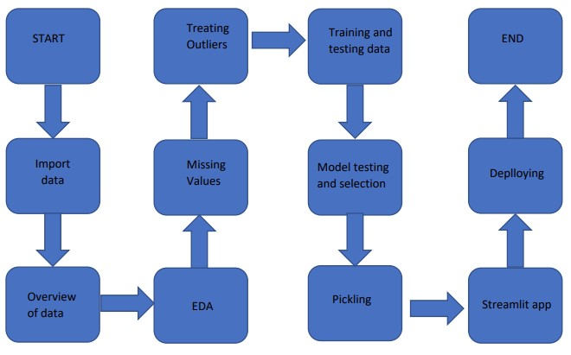](https://user-images.githubusercontent.com/123532199/228265721-f4f5c0d3-5437-4576-bdb5-c8e3d2889a7f.jpg)

**3.2 Deployment Process**

[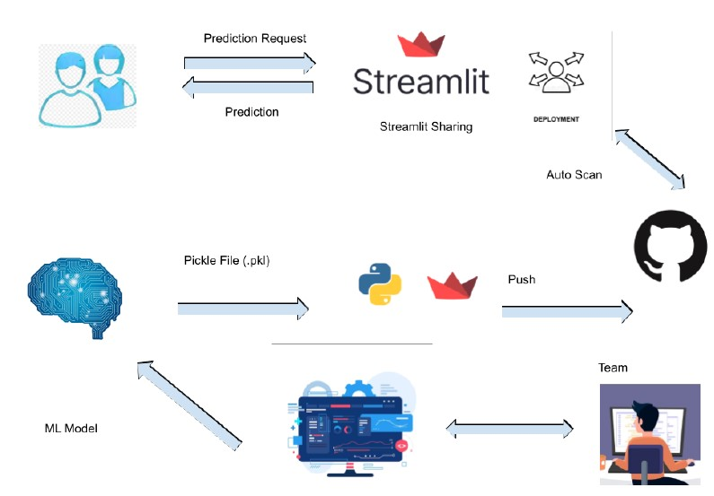](https://user-images.githubusercontent.com/123532199/228271006-a57e95fe-502b-48a5-974c-40dea6fa108d.jpg)

**3.3 Error Handling**

If any error occurred in the processing way, then the error message should be shown to the user in a completely non-technical way that can be understandable by any person. And Meaningful error messages should be shown, so the user can spot his mistake and re-run the process with improvement. All the errors that will occur should be handled properly. And we have to log every error for our application and have to manage the same.

**4. Performance**

The Concrete Compressive Strength Prediction is dependent on a particular ML algorithm that we choose. We will train various ML algorithms and will Evaluate the best fitting algorithm for predicting the target. Our system performance will be based on the data we are going to feed to the algorithms. And the performance will depend on the finalized model. and the web application and the deployment server. With all of these components, our program should run properly.

**4.1 Reusability**

The code and the module are created during the time of building the project should maintain all coding guidelines and full project code is written in a Modular fashion. Our system should have the flexibility to work properly from any location. And it should handle any improper input value from the user and should give a meaningful error message so the user can correct his/her mistake and enter valid input to get the result. And the system should be reusable in every manner with different types of inputs values that are all are it has been trained.

**4.2 Application Compatibility**

The different libraries and Python programming languages are used to build the system. Every library has its own functionality and it should work properly with our fluctuate system. Streamlit will be used for making the web app. All the components of the application should work properly and it should produce a result without any interpretation.

**4.3 Resource Utilization**

Our application should utilize the given resource properly and it should use a minimal amount of internet to work and call the web app. Our system should not use much computational resources hence it will make the application slow. Our application will be deployed on a cloud platform and it should utilize the resource given on the cloud and work properly.

**5. Deployment**

For the deployment process, we will be using Streamlit Sharing cloud to Deploy our model. Streamlit is used to make web apps as well as a cloud platform that lets companies build, deliver, monitor and scale apps.



**6. Conclusion**

In conclusion, concrete compressive strength prediction is a promising technology with a broad range of potential applications in infrastructure fields. Its ability to analyse patterns in concrete ,data can provide valuable insights and predictions that can enhance safety of the infrastructure. With continued advancements in the technology, its scope is likely to expand further, making it a valuable tool for construction industries. Overall, concrete compressive strength prediction has the potential to contribute to a safer society.

**7. Reference**

Google images reference to showcase the framework/library used.

Google docs for drawing process flow and deployment process (flowcharts).